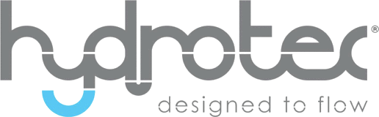

Please feel free to contact our Hydrotec head office:
Address: 5 Boland Street, Charleston Hill Paarl 7646
Email: info@hydrotecsa.com sales@hydrotecsa.com

Cell: 063 173 2843

Account Queries: accounts@hydrotecsa.com
073 288 5774.

CAD Drawing, DWG Files and Technical Data Information available on request.

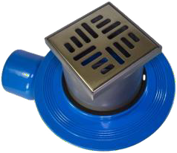
Sales Representatives

Johannesburg
Anzelle - 082 760 2617 anzelle@hydrotecsa.com Adele - 067 088 8527
adele@hydrotecsa.com

Kwazulu-Natal
Seugnet - 063 875 3199 projectskzn@hydrotecsa.com Jordan – 079 377 1224
jordan@hydrotecsa.com

Paarl
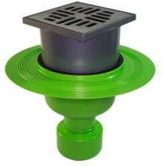
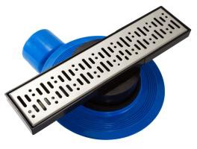
Head Office info@hydrotecsa.com sales@hydrotecsa.com val@hydrotecsa.com andre@hydrotecsa.com

Office:
Andre - 084 528 4534
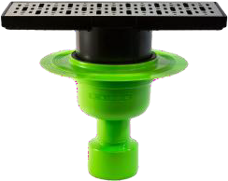
Blanch - 063 173 2843
Gershia - 073 288 5774
Val&Jac - 078 647 6115

SARAHLEE HORIZONTAL – BLUE SARAHLEE VERTICAL - GREEN

